Helm
Helm is a package manager for Kubernetes that simplifies deploying, managing, and upgrading complex applications by packaging Kubernetes manifests into reusable "charts.
Charts bundle YAML templates for resources like Deployments, Services, ConfigMaps, and more, along with metadata and customizable values files.
Helm uses a client-server architecture with the CLI client for managing repositories and releases, while the server-side logic interacts directly with the Kubernetes API.
Automates templating, versioning, rollbacks, and dependency management across environments.​
Enables sharing via public/private repositories, reducing manual YAML maintenance for micro services.​
Supports multi-environment deployments, ideal for CI/CD pipelines in container orchestration.
Here, it is normal way of deployment
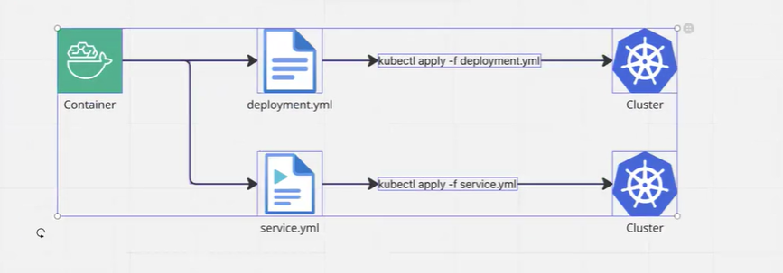

To package your deployment and service YAML files using Helm, you need to create a Helm chart structure including a Chart.yaml and values.yaml file
To package and deploy your Kubernetes application using Helm while avoiding unnecessary commands, follow these steps:
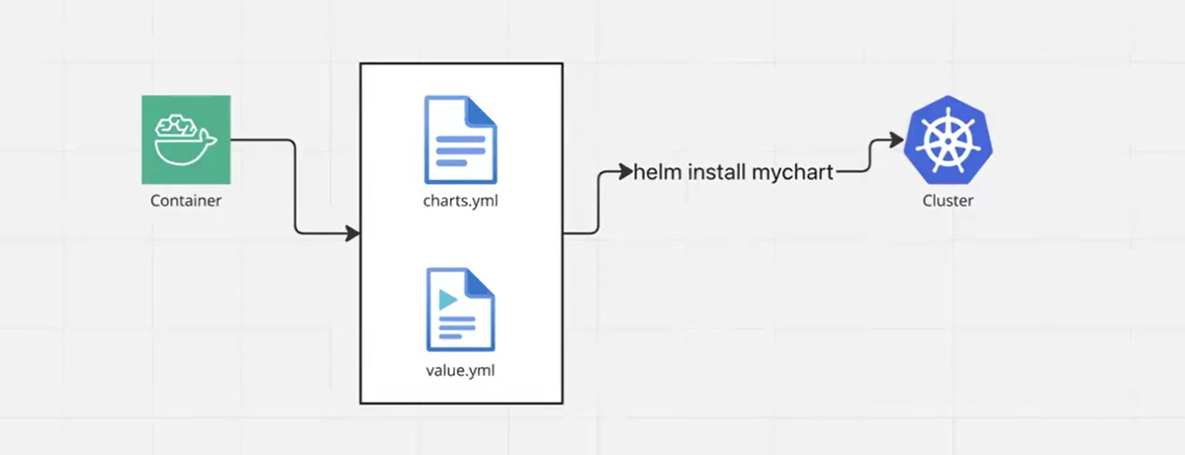
Even it is very easy during roll back. We have to run single command.
When using Kubernetes without Helm, you have to manually delete each resource like pods, deployments, and services individually using kubectl commands. However, with Helm, all these resources are managed as a single release.
This means you can uninstall the entire application (all related Kubernetes objects such as pods, deployments, services, configmaps, etc.) with a single Helm command:
helm uninstall <release-name> [--namespace <namespace>]

This command removes all resources associated with the Helm release, making it much easier and cleaner to delete your application without needing to track and clean up each resource separately. Helm also cleans up the release history unless you use flags to keep it.
In summary, Helm simplifies application removal by letting you uninstall the whole release and all its resources in one step, avoiding the need to delete pods, deployments, services, and other resources separately.

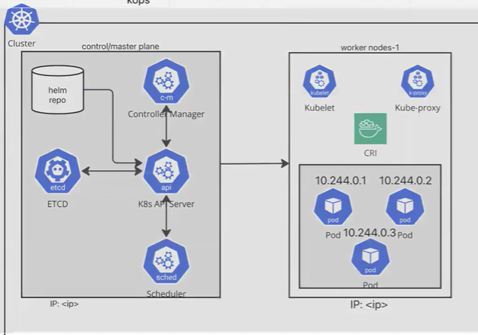
When we install the helm. It will create the helm repo.
Frist we have to create Helm folder.
helm create helloworld generates a complete Helm chart skeleton named "helloworld" in your current directory.
This command creates a production-ready Helm chart template with all necessary files and best practices pre-configured. It scaffolds the standard directory structure including Chart.yaml metadata, values.yaml for configuration, and templated Kubernetes manifests in the templates/ folder.
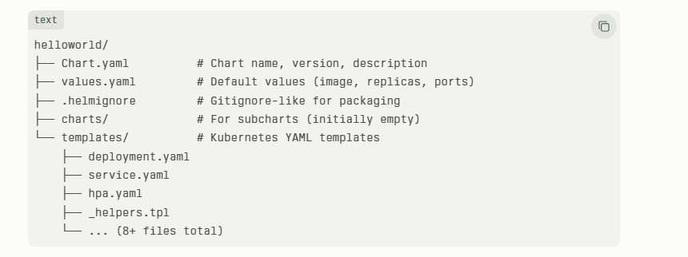

Purpose
Instead of manually creating each file, this gives you a standardized, customizable starting point for packaging your Deployment + Service (or any app) as a reusable Helm chart. After creation, you customize values.yaml and templates/, then package/install with helm package and helm install

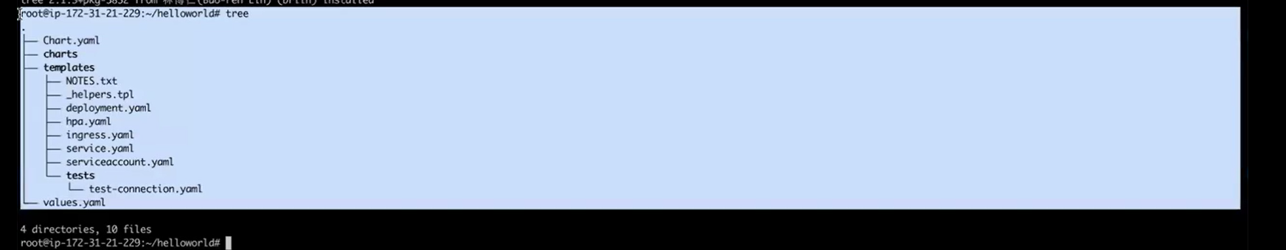

Practical session

- Lunching a server
- Install microk8s
- Install kubectl and do kube config
- Install helm

#!/bin/bash
sudo apt-get update
sudo apt-get install -y curl apt-transport-https
curl https://raw.githubusercontent.com/helm/helm/main/scripts/get-helm-3 | bash
sudo snap install helm --classic
helm version

- We have to create the helm folder
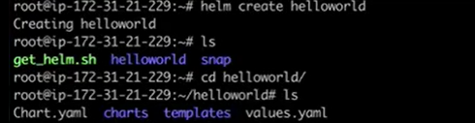
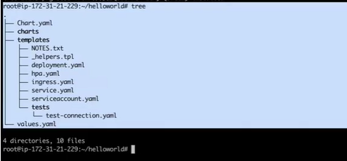
Inside the templates/ folder of a Helm chart, you typically find YAML files that define Kubernetes resources, such as:
deployment.yaml: Defines the Deployment resource for managing pod replicas.
hpa.yaml: Defines the Horizontal Pod Autoscaler for automatic scaling of pods.
ingress.yaml: Defines the Ingress resource for managing external access to services.
service.yaml: Defines the Service resource to expose the application internally or externally.
serviceaccount.yaml: Defines a ServiceAccount to provide an identity for pods.
These template files use Helm's templating syntax to allow customization via the values.yaml file, enabling dynamic configuration of Kubernetes manifests when deploying the chart. This structure helps manage all components of an application in a consistent, scalable way.

- We are going host simple web application.

Value .ymal
values.yaml is like a settings file in your Helm chart. It holds simple values (like numbers, names, or yes/no options) that your app needs
Templates in your chart use these values to create the final Kubernetes files.
For example:
replicaCount: 2 tells it to run 2 copies of your app.
image: nginx:1.20 says which Docker image to use.
servicePort: 80 sets the port number.​
When you run helm install, it reads values.yaml and fills in the blanks automatically.

Vi value.yaml

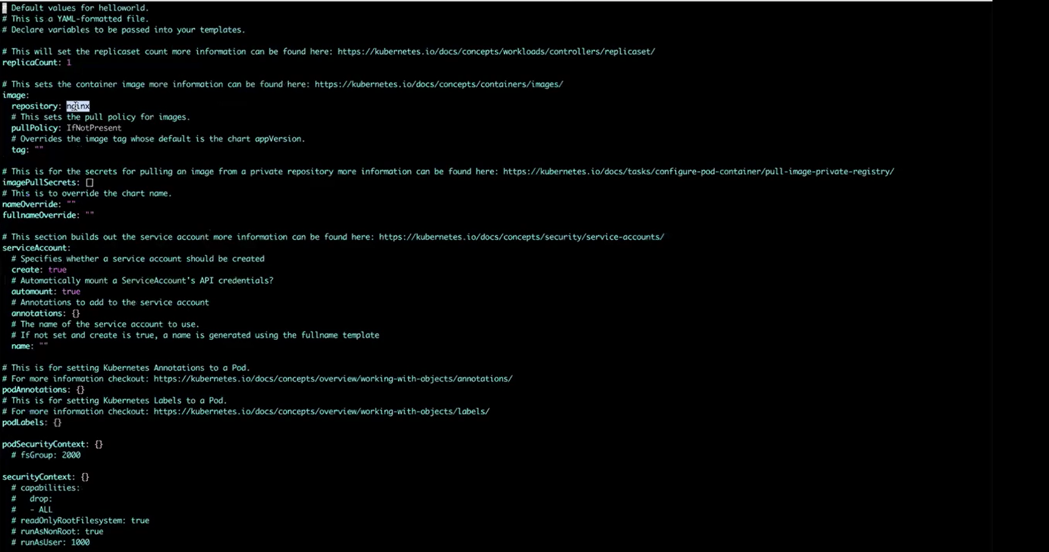

Wehave to go inside the value.yaml give the value like how we are writing yaml.file to lunch the web application.

Open values.yaml and add these simple settings to launch your web app (like Nginx web server):
# Basic web app settings

replicaCount: 1 # Run 1 copy

image:
repository: nginx # Use nginx web server image
tag: "latest" # Latest version
pullPolicy: Always # always pull fresh image

service:
type: NodePort # Makes app accessible from outside
port: 80 # Port users connect to
target Port: 80 # App listens on port 80

resources:
limits:
cpu: "500m" # Max 0.5 CPU
memory: "256Mi" # Max 256MB RAM
requests:
cpu: "100m" # Needs 0.1 CPU minimum
memory: "128Mi" # Needs 128MB RAM minimum

ingress:
enabled: false # Set true later for domain access

- Installing the helm folder
NOTE:
helm install myimage helloworld
helm install = Command to deploy your app
myimage = Release name (your app's nickname in Kubernetes)
helloworld = Chart folder name (path to your Helm chart directory)
helm install [release-name] [chart-path]
Helm reads ./helloworld/ folder (your chart)
Uses values.yaml to fill templates
Creates nginx pods + LoadBalancer service
Names everything with "myimage-" prefix
helm install myimage helloworld
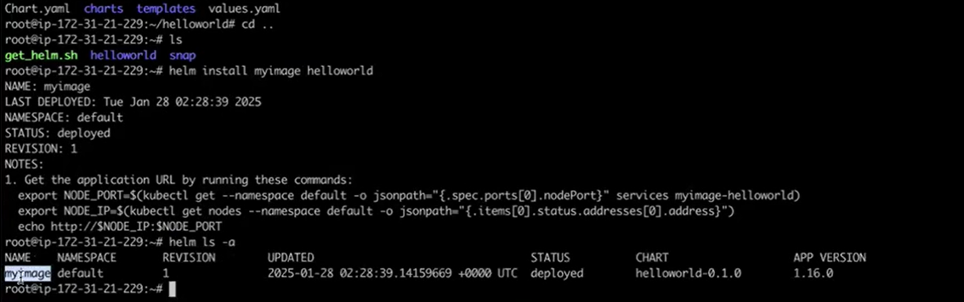
helm list -a (or helm ls -a) lists ALL Helm releases including deployed, failed, pending, superseded, and uninstalled ones.
Automatically created below things
Kubectl get pods
Kubectl get deployment
Kubectl get svc
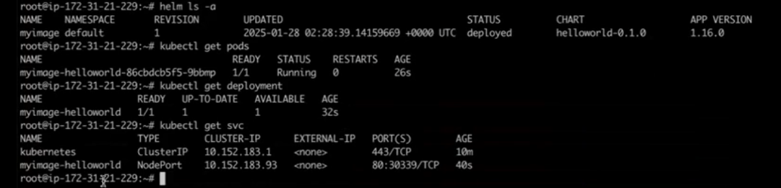

Take the port value from Nodeport 30339
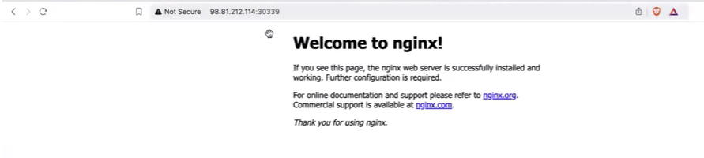

Helm commands

- Helm create
Helm create command generates a new Helm chart directory with a complete scaffold structure, including essential files like Chart.yaml, values.yaml, and Kubernetes templates.
helm create my-chart
This creates a directory named my-chart with the following structure:
my-chart/
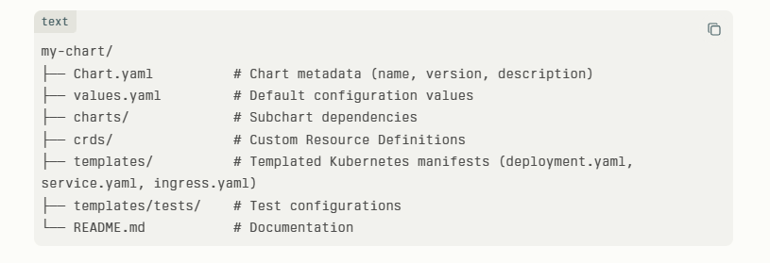
Edit Chart.yaml for metadata like apiVersion: v2 and appVersion.​
Modify values.yaml to set defaults (e.g., replicaCount: 1, image: nginx:1.16.0).​
Customize templates in templates/ using Go templating and Helm functions like {{ .Values.image.repository }}.​
Run helm lint my-chart to validate, then helm package my-chart to package for distribution. This scaffold provides a production-ready starting point for custom applications.

- helm install

The helm install command deploys a Helm chart as a release into a Kubernetes cluster.

The helm install command deploys a chart as a release using the syntax:

helm install [RELEASE] [CHART] [flags]

Flag | Purpose | Example
-f, --values | Load values from YAML file(s) | helm install my-release ./my-chart -f values.yaml -f override.yaml
--set | Inline key=value overrides | helm install my-release ./my-chart --set replicaCount=3,image.tag=v1.0
--namespace, -n | Target namespace | helm install my-release ./my-chart -n prod --create-namespace
--dry-run | Preview manifests | helm install my-release ./my-chart --dry-run
--wait --timeout=5m | Wait for readiness | helm install my-release ./my-chart --wait --timeout=10m

---------------------------------------------------------------------------------------------------------------------------------------------------
- helm upgrade

The helm upgrade command updates an existing release to a new chart version or configuration
It is used to upgrade the existing file such as upgrade the resource type or size.

Syntax: helm upgrade [RELEASE] [CHART] [flags].

Flag | Purpose | Example
-f, --values | Apply YAML values files | helm upgrade my-release ./my-chart -f values.yaml -f prod.yaml
--set | Inline overrides | helm upgrade my-release ./my-chart --set image.tag=v2.0
--reuse-values | Keep previous values | helm upgrade my-release ./my-chart --reuse-values --set new.key=value
--reset-values | Use only chart defaults | helm upgrade my-release ./my-chart --reset-values
--dry-run | Preview changes | helm upgrade my-release ./my-chart --dry-run
--atomic | Rollback on failure | helm upgrade my-release ./my-chart --atomic --timeout=5m

For example:
We have to increase the count of pods such as previously it was 1 and need to make 2.Go to Value.yaml and do the changes make replicas: 2.Then, we have to run the below command.
go to main folder
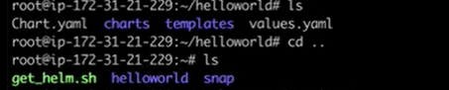
Here, inside the helloworld all the files exist such as chart.yaml, charts, templates, values.yaml.
Helm upgrade myimage helloword
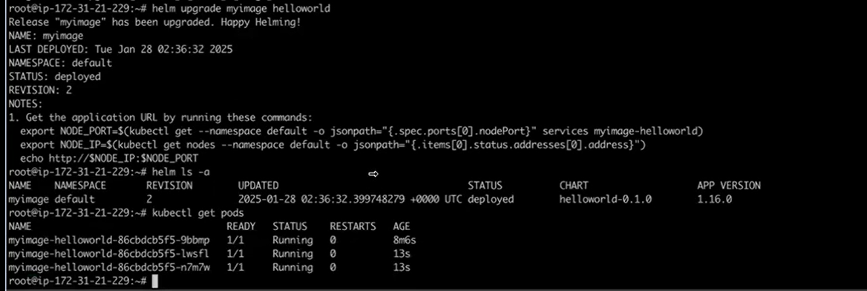

Note:
In Helm charts, the `templates/` directory contains multiple YAML template files like `deployment.yaml`, `service.yaml`, `configmap.yaml`, and others, each defining a specific Kubernetes resource.
Vi deployment.ymal: here we are not doing any configuration. For vi deployment and other file getting the values from value.yaml.
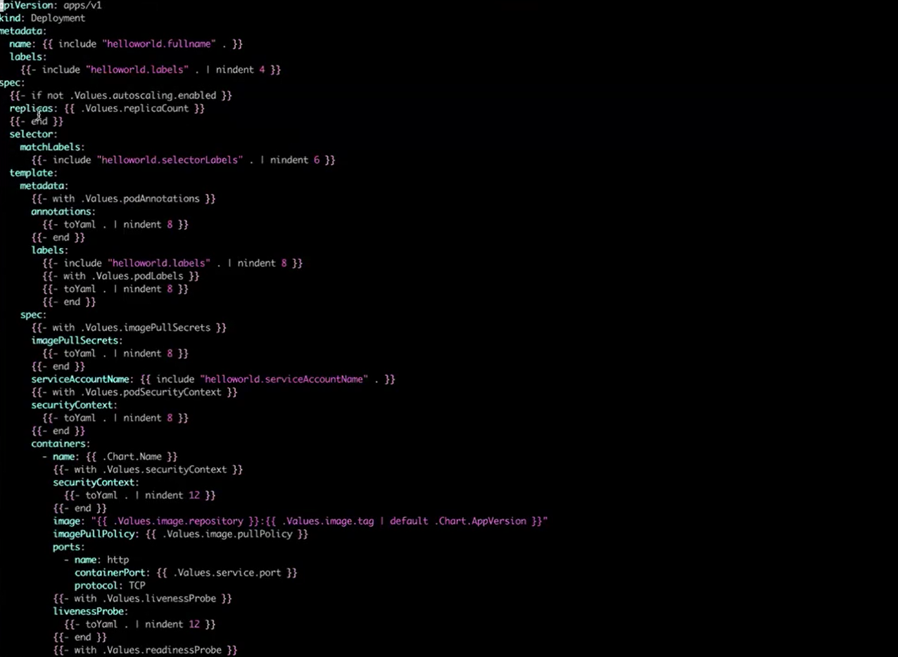
Instead we do the configuration or give the values inside the value.ymal. all the file inside the templates folder getting the value for value.yaml.
--------------------------------------------------------------------------------------------------------------------------

- Helm rollback
the helm rollback command reverts a release to a previous revision using the
syntax:
helm rollback [RELEASE] [REVISION] [flags].​

RELEASE] is the name of the Helm release you want to roll back.
[REVISION] is the specific revision number to roll back to. If omitted, it rolls back to the immediately previous revision.
[flags] are optional flags to customize the rollback behaviour.

For example, to roll back a release named my-release to revision 1, you would run:
text
We want pervious revision means what change we have made that not required we want pervious revision.

Helm rollback myimage 1

So, we are in the previous revision.
Flag | Purpose | Example
--dry-run | Simulate rollback without changes | helm rollback my-release 1 --dry-run
--wait | Wait for resources to be ready | helm rollback my-release 1 --wait --timeout=5m
--force | Force via delete/recreate | helm rollback my-release 1 --force
--no-hooks | Skip hook execution | helm rollback my-release 1 --no-hooks
--cleanup-on-fail | Clean failed new resources | helm rollback my-release 1 --cleanup-on-fail

It is used to go back to previous version or changes
---------------------------------------------------------------------------------------------------------------------------------------------------
- Helm template
the helm template command generates Kubernetes manifest files from a Helm chart locally, without installing them. It processes the templates with values and outputs YAML files you can review or save.

Basic syntax:
helm template [RELEASE] [CHART] [flags]
RELEASE: name for the deployment
CHART: path or name of the chart
flags: options like custom values or namespace
Use it to check or debug manifests before applying them to a cluster.

- Helm Lint

Helm lint validates a Helm chart for syntax errors, best practices, and potential issues before Kubernetes deployment.​
Run it with helm lint <chart-directory> to check Chart.yaml, values.yaml, and templates for problems like invalid structure or rendering failures

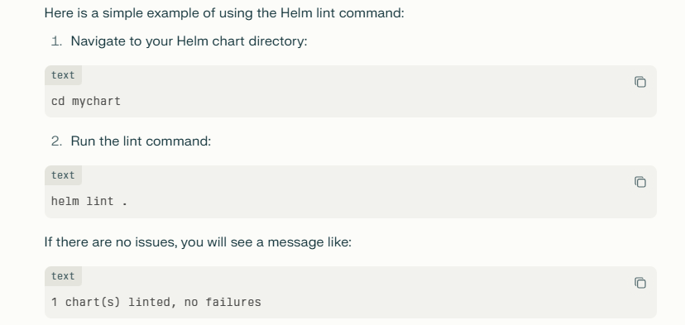
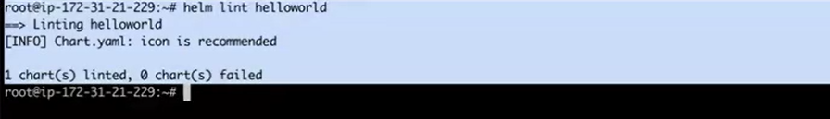

- Helm uninstall
It is used to remove the helm release means resource created by the helm
Run helm uninstall <release-name> to delete the release.
For a specific namespace, use
helm uninstall <release-name> -n <namespace>

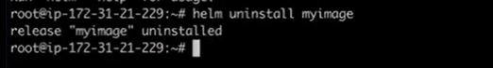
--------------------------------------------------------------------------------------------------------------------------

NOTE:
Some time we don’t want to install the helm or run the helm folder we go for below it is work same as terraform plan. It will give the information about what will happen instead of installing helm.

helm install testing ./helloworld --debug --dry-run
The command helm install testing hellword --debug --dry-run simulates installing a Helm release named "testing" from a chart directory or path called "hellword" without making changes to the Kubernetes cluster. It renders templates locally or against the cluster (depending on dry-run mode), validates manifests via the Kubernetes API, and outputs detailed YAML with debug information for troubleshooting. This catches syntax errors, validation issues, or template problems before actual deployment.
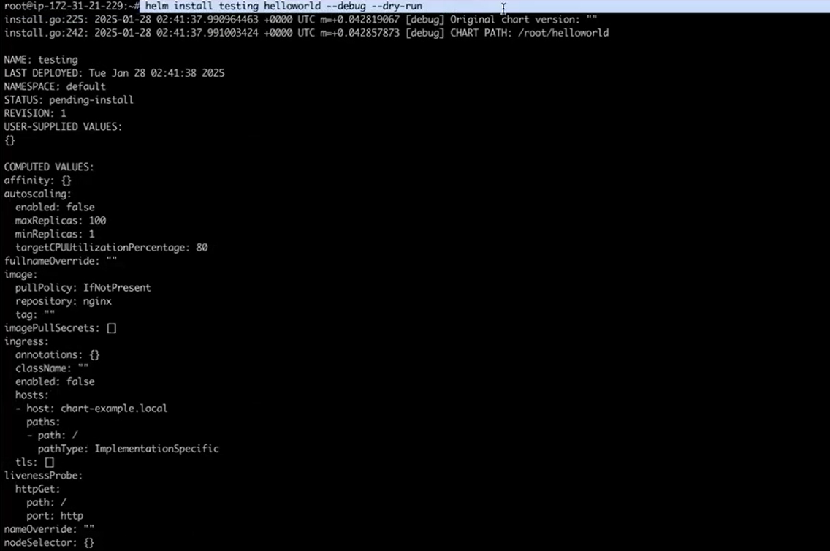
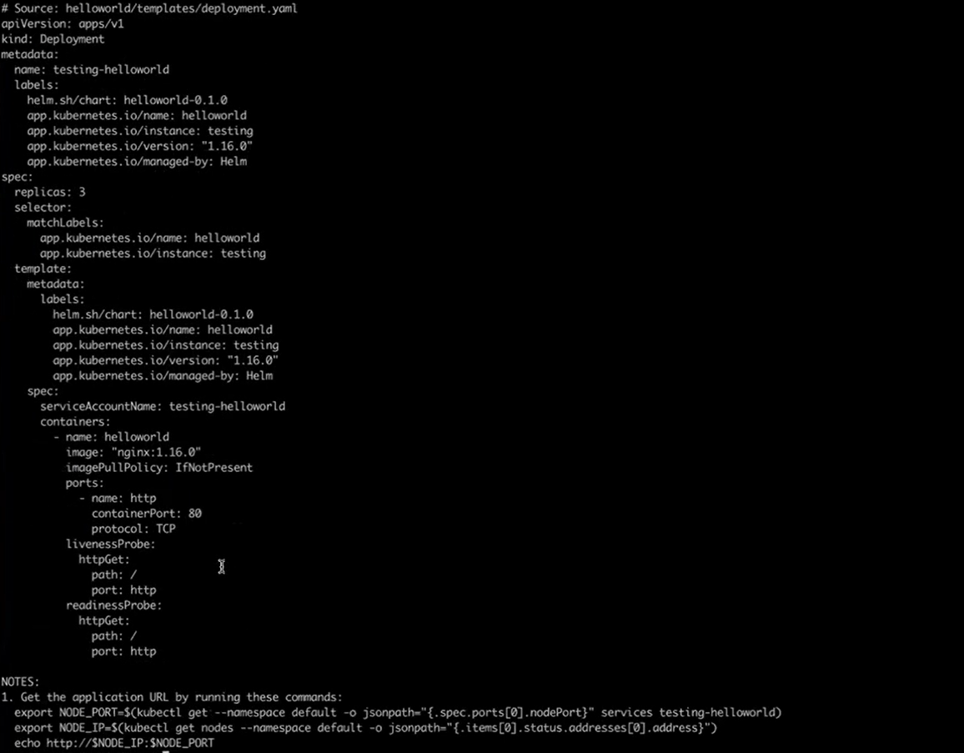

Dry-Run Modes
Mode | Behaviour | Cluster Required
--dry-run=client | Local rendering only, no API calls | No helm​
--dry-run=server | Full validation against cluster | Yes helm+1​

Deploying python based application

FROM python:3.8-slim
WORKDIR /app
COPY ./app
RUN pip --no-cache-dir install -r requirements.txt
CMD ["python", "main.py"]
Main.py
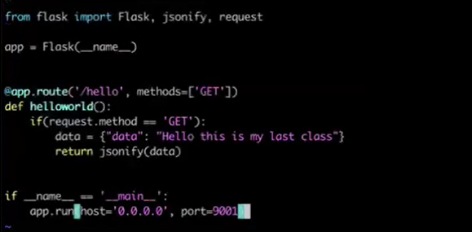

FROM python:3.8-slim - Specifies the base image from Docker Hub, pulling the official Python 3.8 runtime environment (full variant, ~900MB). This provides Python interpreter, standard libraries, and OS dependencies for your app.
WORKDIR /app – creating a folder app inside the container.
COPY. /app moving application code file (main.py) to app folder inside the container.
RUN pip --no-cache-dir install -r requirements.txt the command RUN pip --no-cache-dir install -r requirements.txt installs all Python packages listed in requirements.txt inside the Docker image during build time. Using --no-cache-dir prevents pip from storing cache files, reducing the image size. Placing this command after copying only requirements.txt allows efficient layer caching, so dependencies are not reinstalled if only the application code changes.
CMD ["python", "main.py"] The Docker file command CMD ["python", "main.py"] defines the default instruction to run when a container starts from the built image. It executes the Python interpreter to run the main.py script inside the container. This is the main entry point of your application, which can be overridden by specifying a different command when running the container. Using the exec form (JSON array) ensures there is no shell wrapping, providing more predictable signal handling.
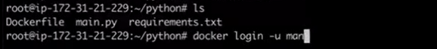
Note:
FastAPI (likely intended as "fask" refers to this framework, given context from prior queries) is a modern, high-performance Python web framework for building APIs, using standard type hints for automatic data validation, serialization, and documentation generation.​
What is 404 error
A 404 error means the server cannot find the requested webpage or resource, often due to a wrong URL or deleted page?
Final output:
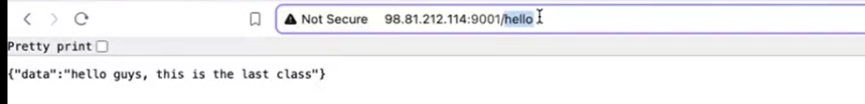

---------------------------------------------------------------------------------------------------------------------------

ARGO CD

Argo CD is a GitOps tool for Kubernetes that auto-syncs app states from Git repos to clusters.​
Speeds deployments, UI/CLI visualization, Helm/Kustomize integration; Git as single truth for fast rollouts/rollbacks in Jenkins/EKS pipelines
Installation script

#!/bin/bash
kubectl create namespace argocd
kubectl apply -n argocd -f https://raw.githubusercontent.com/argoproj/argo-cd/stable/manifests/install.yaml
argocd namespace will be created.
Deploys all Argo CD components to the argocd namespace in your Kubernetes cluster.

kubectl get svc –n argocd
kubectl patch svc argocd-server -n argocd -p '{"spec": {"type": "LoadBalancer"}}'
kubectl get svc -n argocd lists all services in the Argo CD namespace, showing current service types (ClusterIP/NodePort/LoadBalancer) and ports.
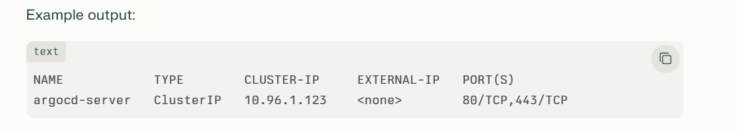
using kubectl patch svc argocd-server -n argocd -p '{"spec": {"type": "LoadBalancer"}}' command we are changing the type clusterIp to load balancer.
OR

Another way to change the type in the service file:-
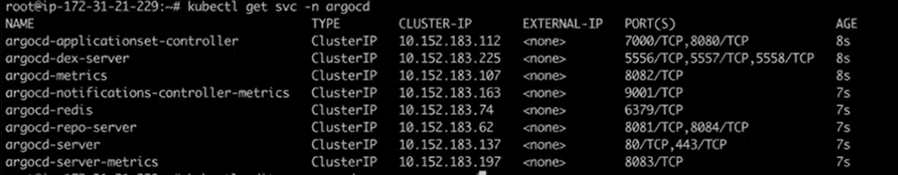
Kubectl get svc –n argocd
Kubectl edit svc argocd-server –n argocd
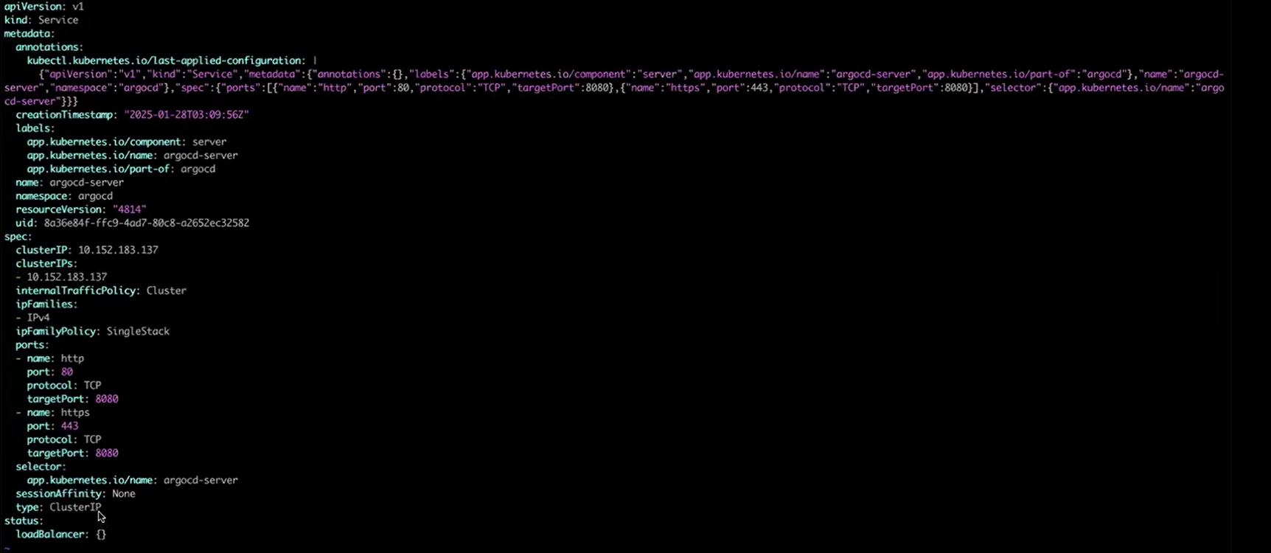
Edit and save
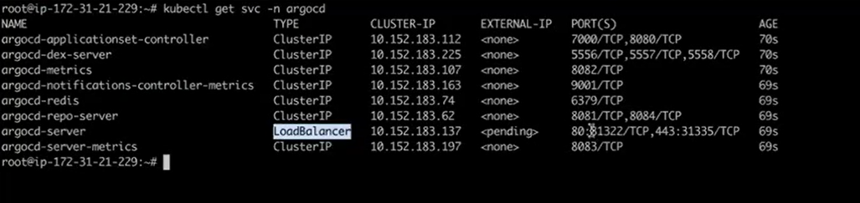

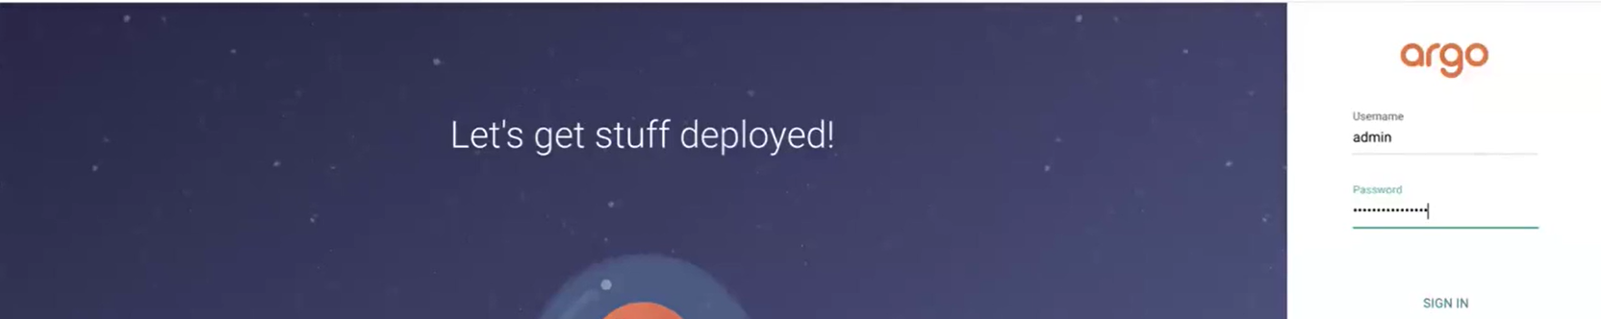

Generating password for Argo-CD login
Extracts and decodes the base64-encoded initial admin password from Argo CD's bootstrap secret.
kubectl -n argocd get secret argocd-initial-admin-secret -o jsonpath="{.data.password}" | base64 –d
Step-by-Step
kubectl -n argocd get secret argocd-initial-admin-secret → Fetches the admin secret
-o jsonpath="{.data.password}" → Extracts base64-encoded password field
| base64 -d → Decodes to plain text

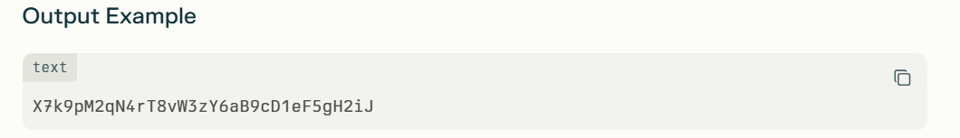
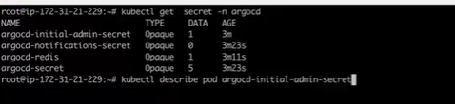

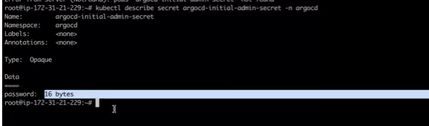
It will show the password 16byte but password is not displayed here.
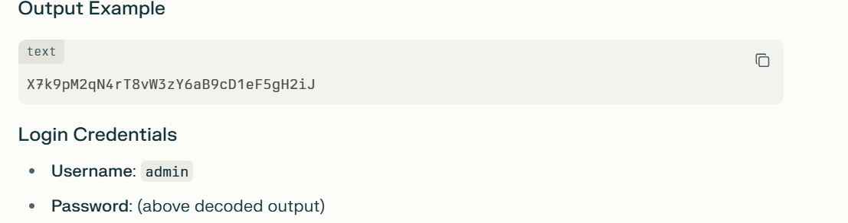

We need a folder which consists all the file such as deployment.yaml, service.yaml, and create git repo create folder argocd.
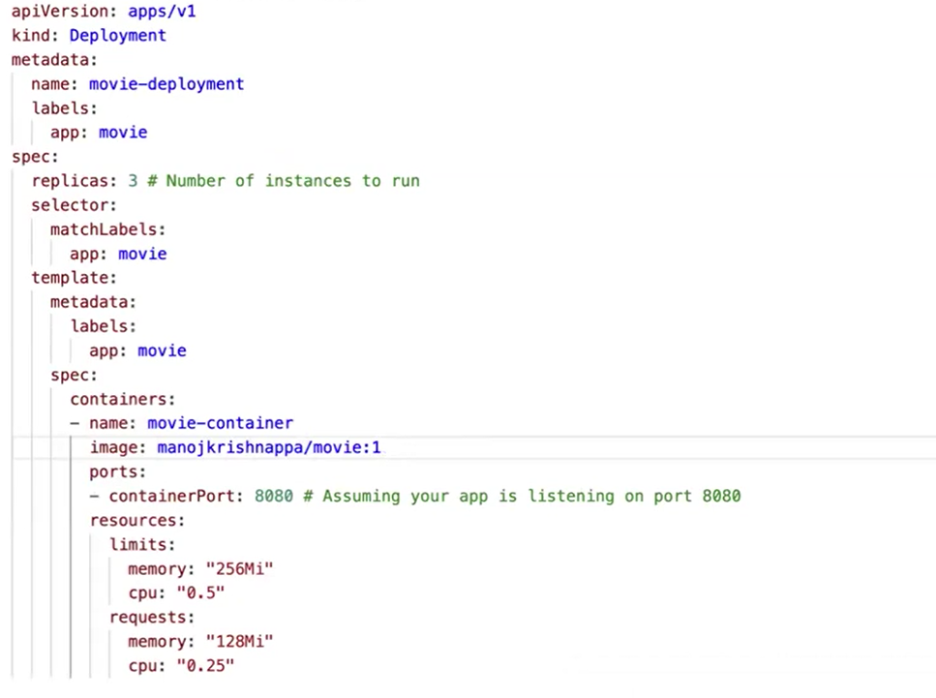
Service folder.yaml
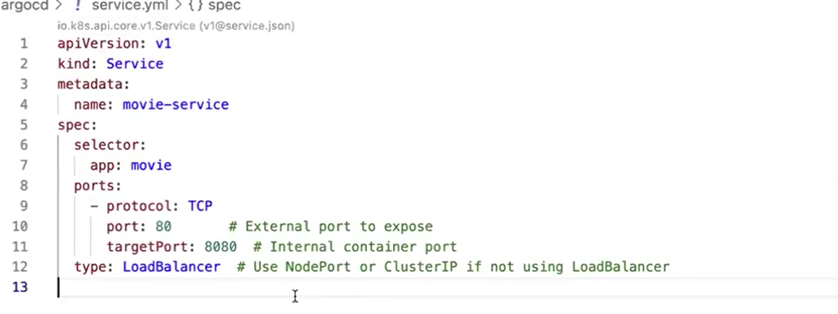
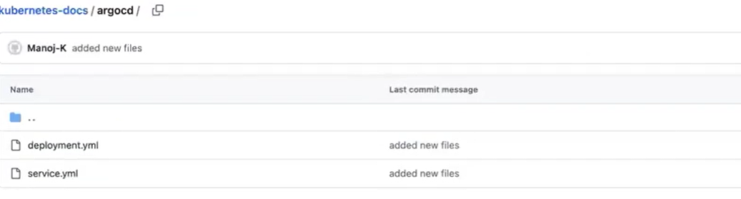

Go to argocd dashboard
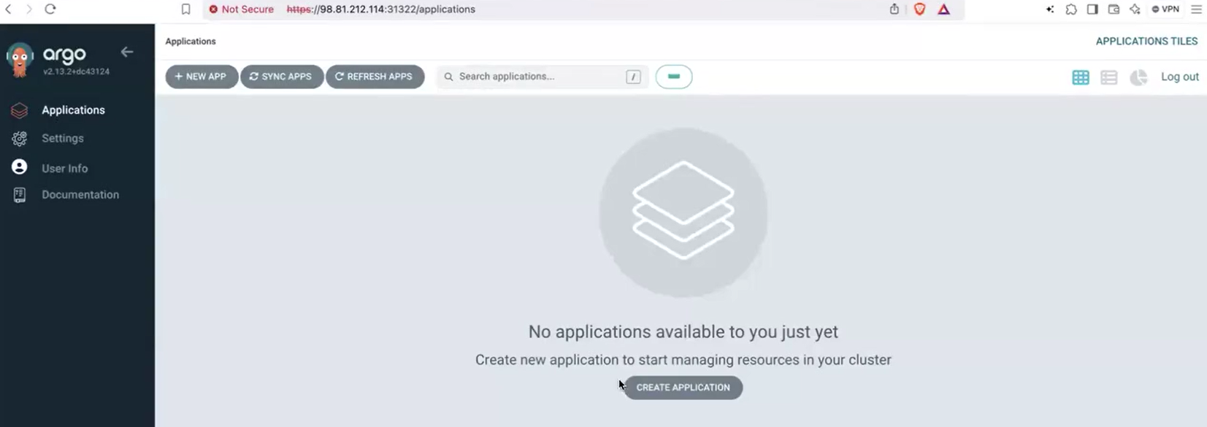
Step 1: Create application
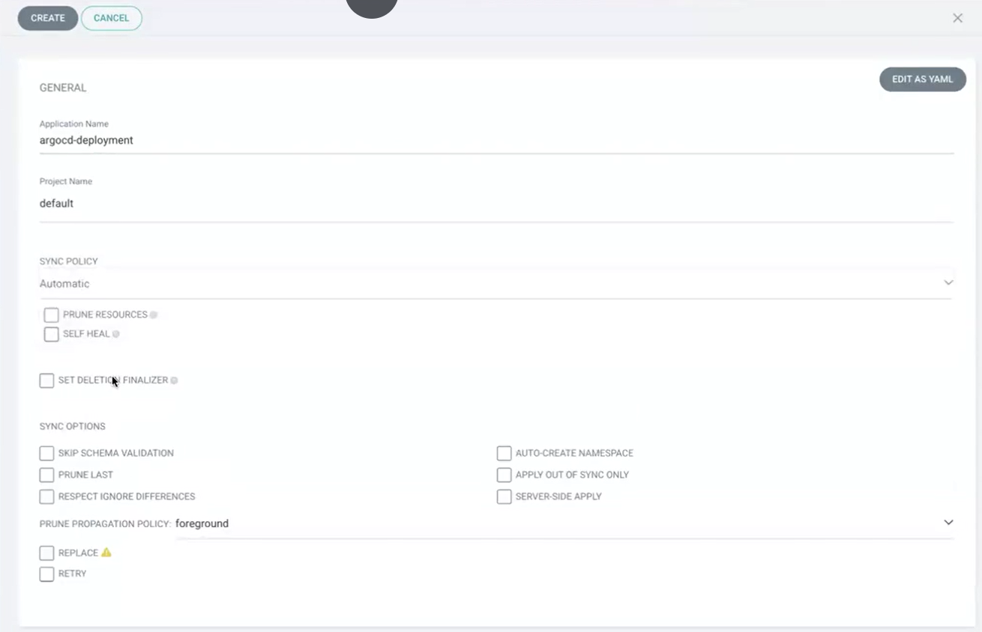
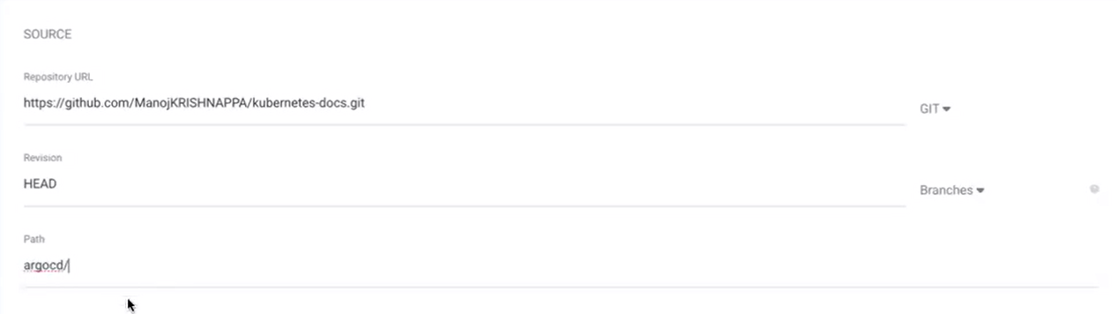
Provide the git hub link in source section.
Path= provide folder path.
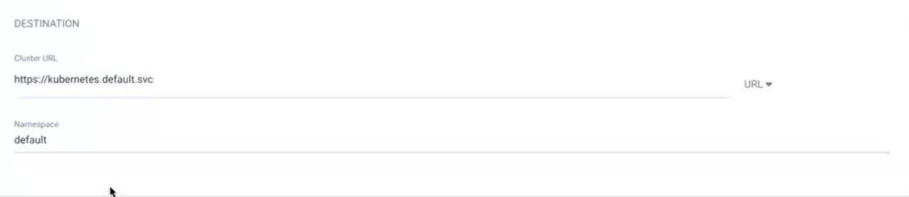
Click on create.
application is being deployed
